

**Electronics & Measurements Laboratory Manual**

**Laboratory Manual**

**Electronics & Measurements Laboratory**

**Department of Electronics & Instrumentation Engineering**

**VALLURUPALLI NAGESWARA RAO VIGNANA JYOTHI INSTITUTE OF ENGINEERING & TECHNOLOGY**

**AN AUTONOMOUS INSTITUTE**

**Approved by AICTE, New Delhi and Govt. of T.S. & Affiliated to JNTUH Accredited by NBA and NAAC with ‘A’ Grade**

Vignana Jyothi Nagar, Bachupally, Nizampet (S.O.), Hyderabad - 500 090. Telangana State, India.

(22PC2EI212) ELECTRONIC AND MEASUREMENTS LABORATORY

# **COURSE OBJECTIVES**:

# • To identify various semiconductor diodes and transistors

# • Understand the characteristics and frequency response of semiconductor devices

# • To make students design basic measuring circuits like bridges

# **COURSE OUTCOMES:** After completion of the course, the student should be able to

# CO-1: Understand the specifications of various semiconductor devices and their characteristics

# CO-2: Analyze the frequency response of various semiconductor devices

# CO-3: Appreciate the use of various bridges for measurement of R, L and C

**List of Experiments:**

# 1. V-I characteristics of PN junction diode and Zener diode under forward and reverse bias.

# 2. Full-wave Rectifier without filter and with filters

# 3. Input and Output characteristics of CE transistor configuration

# 4. Input and Output characteristics of CB transistor configuration

# 5. Input and Output characteristics of CC transistor configuration

# 6. Characteristics of FET

# 7. Frequency response of CE Amplifier.

# 8. Frequency response of CS Amplifier.

# 9. Measurement of resistance using wheat stone bridge.

# 10. Measurement of low resistance using kelvin bridge.

# 11. Measurement of capacitance using Schering bridge.

# 12. Measurement inductance using Maxwell’s bridge and measurement of L, C and R using Q meter.

EXP-1

V-I CHARACTERISTICS OF PN JUNCTION DIODE AND ZENER DIODE UNDER FORWARD AND REVERSE BIAS

EXP- 1A.

**V-I CHARACTERISTICS OF PN JUNCTION DIODE**

**Aim:**

a) To plot the V–I characteristics of a Semiconductor PN – Junction diode.

1. b) To find the following parameters from the Forward & Reverse characteristics.

i) Cut in voltage-Vγ

ii) Static forward resistance RF

1. iii) Reverse saturation current-Ico
2. iv) Dynamic forward resistance-rf

v) Dynamic reverse resistance-Rr

**Apparatus:**

1) A PN Junction Diode (DR25 / 1N4148), 180Ω & 10K.Ω Resistors

2) Power Supply (0-30V)

3) Digital multimeter (0-1V)

4) Ammeter (0-100mA)

5) Ammeter (0-500µA)

**Circuit diagram:**

**Forward characteristics of a Diode is shown in Fig.1.**

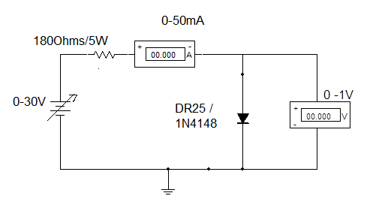

**Fig.1**

**Theory :**

Under forward bias configuration the positive terminal of the battery is connected to P-side and negative terminal of the battery is connected to N-side as shown in the figure above. Large amount of current flows through the junction under this condition.

When P-N junction is forward biased, the holes are repelled from the positive electrode and the electrons from the negative electrode of the power supply, and are forced to move towards the junction. Some of the holes and electrons in the depletion region recombine themselves. This reduces the width of the depletion layer and the height of the potential barrier. As a result of this more number of majority charge carriers flow through the P-N junction.

**Procedure :**

1. Ensure that D.C Power supply is switched OFF. Keep the voltage control knob in the minimum position and current control knob in maximum position.
2. Connect the circuit as shown in Fig –1 for forward characteristics making use of silicon diode.
3. Vary the power supply voltage such that the voltage across the diode is varied 0-1V in steps of 0.1 volts .Note down Vf and If in the table.
4. Draw the Vf , If characteristics and find out the cut – in voltage Vr for diode from it.

Ensure that the current through the diode does not exceed 50mA.

v. Repeat the experiment using germanium diode.

1. vi. Present the results at the end of the experiment.
2. vii. Estimate the forward resistance of the diode from the relation = [Δ Vf / Δ If ]

**Circuit diagram:**

**Reverse characteristics of a Diode is shown in Fig.2.**

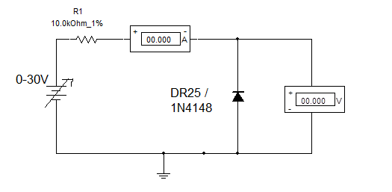

**Theory :**

In the reverse bias positive electrode of the battery is connected to N-side and the negative electrode to P-side. When a P-N junction is reverse biased, the holes in the P region are attracted towards the negative electrode of the battery and the electrons in the N region are attracted towards the positive electrode.

Thus the majority carriers are drawn away from the junction. This widens the

Depletion layer and increases the height of the potential barrier. Hence there is no current flow due to majority carriers under reverse bias. A small amount of current due to diffusion of minority charge carriers across the junction flows through the reversed biased PN junction. Generation of the minority carriers is dependent upon the ambient temperature and is independent of the applied reverse voltage, as can be seen from the graph.

**Procedure:**

1. Connect the circuit as shown in Fig-2 for reverse bias characteristics making use of a

Silicon diode

1. Vary the voltage across the diode from 0-20 volts in steps of 1V and record the reverse saturation current in µA.

iii. Draw the reverse characteristics Vr, Ir .

iv. Find out the reverse saturation current Ir. Estimate the reverse resistance Rr from the

Characteristic curve from the relation Rr = [Δ Vr / Δ Ir]

v. Repeat the experiment using germanium diode.

vi. Present the results at the end of the experiment.

**Forward Characteristics Reverse Characteristics**

TABLE-I TABLE-II

|  |  |
| --- | --- |
| Vf  (Volts) | If  (mA) |
| 0.0  0.1  -  -  -  -  -  -  1.0 |  |

|  |  |
| --- | --- |
| Vr  (Volts) | IR  (µA) |
| 0.0  2.0  -  -  -  -  -  20.0 |  |

**Forward and Reverse Characteristic curves :**

The observations are plotted in Fig.3

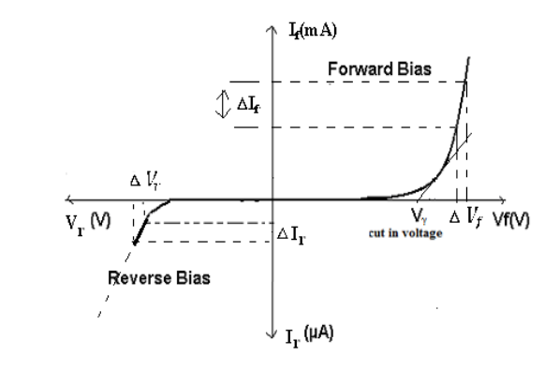

**Results:**

The parameters of the Silicon and Germanium diodes are estimated from the static forward and reverse characteristics and are presented below.

The Cut-in Voltage of Si diode is = __________ V

The Static resistance of the diode in forward bias = __________

The Dynamic Resistance of the diode in forward bias = __________

**Discussions:**

1. What are the cut-in voltages for the two diodes used ? Give reasons why they are different?

2. What is meant by forward and reverse bias ?

3. Name the applications of the diodes.

4. What is meant by depletion layer or intrinsic / Space charge region

5. What is meant by recombination?

6. Write examples of N type & P type materials?

7. What is reverse Saturation Current?

**EXP- 1B**

ZENER DIODE CHARACTERISTICS

**Aim :**

To Plot the V – I Characteristics of a Zener diode.

**Apparatus :**

i. Circuit Board containing 8Z2 Zener diode, 180Ω & 10K.Ω Resistors

ii. Regulated Power supply ( 0-30V)

iii. Ammeters (0 - 50mA) – 3 No.s

iv. Decade Resistance Box

v. Voltmeter (0-20V)



**Circuit**

**Zener Diode under Reverse Bias :**

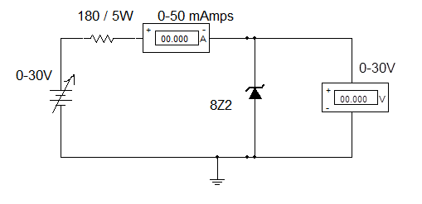

**Fig.1**

**Theory:**

When the Zener Diode is operated under forward biased condition it behaves exactly similar to an ordinary P-N Junction Diode. It exhibits the same identical characteristics.

The Zener diode is a Silicon PN junction device. It is operated in the reverse breakdown region. When a reverse voltage across a diode is increased a critical voltage called a breakdown voltage is reached at which the reverse current increases rapidly. The reverse breakdown of a PN junction may occur either due to Avalanche breakdown effect or Zener breakdown effect or both.

**Procedure:**

i. Connect the circuit as per the Diagram shown in Fig –1

ii. Ensure that the power supply is switched OFF. Keep the voltage control knob in the

minimum position and current control knob in maximum position.

iii. Vary the power supply such that the increment in the input voltage, Vi is 2V.

Record the corresponding values of Vz voltage across the Zener Diode and Iz current

through the Zener as shown in Table-I. Do not exceed the Zener current Iz more than

the 50 mA.

iv. Plot V – I characteristics of Zener diode in reverse bias region as shown in graph

Identify the Zener break down voltage Vz.

v. Calculate the resistance of the Zener diode in the linear part of the breakdown region

with the help of the formula Rz = [Δ Vz / Δ Iz ]

vi. Present the results at the end of the experiment.

**Table-I: v – i characteristics of Zener diode Under Reverse Bias**

|  |  |  |
| --- | --- | --- |
| **SUPPLY VOLTAGE**  **Vi (volts)** | **VOLTAGE ACROSS ZENER**  **Vz (Volts)** | **CURRENT THROUGH ZENER Iz(ma)** |
| **0.0**  **20.0** |  |  |

**RESULTS:**

i. Zener breakdown voltage Vbr =

ii. Zener resistance in the breakdown region Rz =

**Discussions:**

i. Name the applications of Zener diodes?

ii. Explain Zener effect and avalanche effect?

iii. Why Zener diode characteristics are taken in reverse bias?

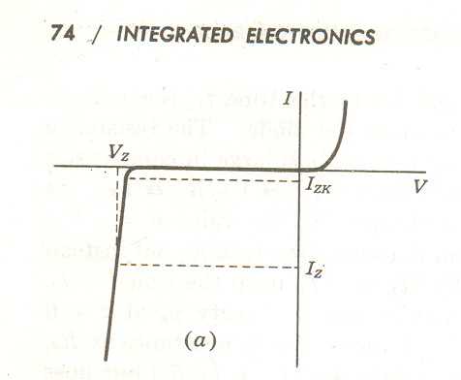 **Expected Graph:**

Rz = [Δ Vz / Δ Iz ] Ir

**EXP-2**

# **FULL-WAVE RECTIFIER WITHOUT FILTER AND WITH FILTERS**

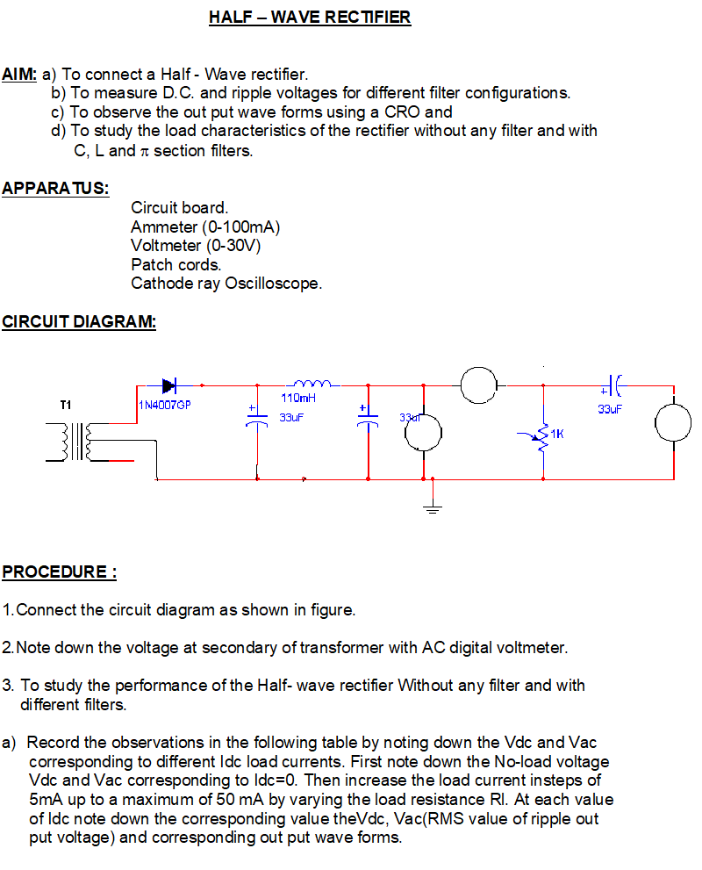

**TABLE**

|  |  |  |  |  |  |
| --- | --- | --- | --- | --- | --- |
| Idc  (mA) | Vdc  (volts) | Vac  V(rms) | RL = Vdc / Idc | Ripple factor  ρ=Vac/Vdc | %Regulation  r={(Vnl-Vl)/Vnl }x100 |
| 0  5  10  .  .  .  50 | * |  |  |  |  |

*Note -Vdc corresponding to Idc=0 will be the no-load voltage = Vnl.

Plot the graphs a) Idc vs Vdc b) Calculate the % of regulation at different load currents and

Plot the graph as shown in the diagram using the formula.

% Regulation r = {(Vnl-Vl)/Vl} x 100 , Idc = constant (=25mA),ripple factor will be zero at Idc=0(since Vnl and Vl be the same at Idc=0 ).

ρ = Iac / Idc = Vac / Vdc.

4. To study the performance of Half-wave rectifier without any filter and with different filters repeat the experimental procedure of step 3 in corresponding to 1.Shunt capacitor filter 2. Inductor filter. 3.L-section filter 4. π - section filter.

Compare the result of step 3 and 4 with theoretical values.

**Model Graphs :**

**% Regulation**

**Vdc**

**Idc Idc**

**With out filter**









EXP-3

STATIC CHARACTERISTICS OF TRANSISTOR

IN COMMON BASE CONFIGURATION

**Aim :**

To obtain the input and output characteristics of the given transistor in CB configuration.

**Apparatus :**

i. Circuit board containing CL100 Transistor, Resistors

ii. Ammeters (0-50mA) – 2 Nos.

iii. Voltmeters (0-1 V,& 0-30 V)

iv. Patch cords.

v. Regulated Power Supply.

1. **Input Characteristics :**

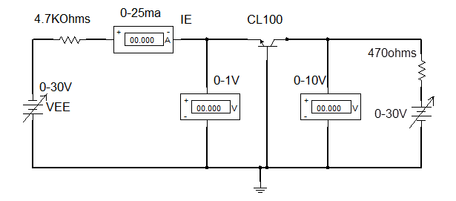

Fig.1

Theory:

Input characteristic curves give the relationship between the emitter current [IE]

and the emitter to base voltage[VEB] for a constant collector to base voltage [VCB]. As the collector to base voltage (VCB) is increased above one volt, the curve shifts upwards. It occurs due to the phenomenon called “Base width Modulation” or “Early Effect”.

**Procedure:**

i. Connect the circuit as shown in Fig-1.

ii. Ensure that the power supply is switched OFF. Keep the voltage control knob in the

minimum position and current control knob in maximum position.

iii. Switch ON the power supply. Adjust Vcc such that Vcb is zero.

1. iv. Vary IE with the help of VEE in steps( say 2mA )and record the corresponding
2. values of VBE  in the Table-I shown below. Make sure that the collector current, Ic
3. does not exceed 25mA.

v. This set of observations gives the input characteristics With VCB=0V.

1. vi. Repeat steps from 1 to 4 for different values of VCB say VCB = 5V , 10V and for
2. VCB open (This can be done by opening one of the out put terminals.)

vii. Draw the input characteristics IE Vs VEB for different values of VCB as shown In

Fig.3(a).

viii. Present all the results at the end of the experiment.

**Table-I: Input Characteristics**

|  |  |  |  |  |  |  |  |  |
| --- | --- | --- | --- | --- | --- | --- | --- | --- |
| S. No. | VCB = 0 V | | VCB = 5 V | | VCB = 10 V | | VCB = OPEN | |
| IE  (mA) | VEB  (V) | IE  (mA) | VEB (V) | IE  (mA) | VEB (V) | IE  (mA) | VEB (V) |
| 1  2  3  .  . | 0  5  10  15  20  25 |  |  |  |  |  |  |  |

**2. Output Characteristics**:

The Circuit diagram for the study of output characteristics of a Transistor in common-base configuration is shown in Fig.2.

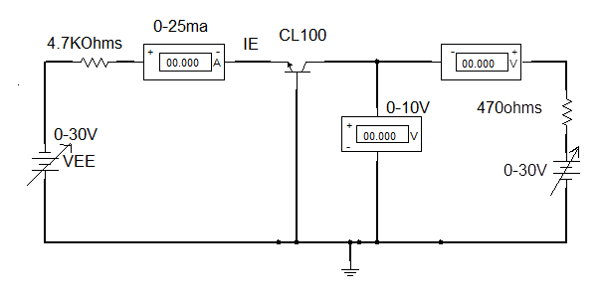

**Fig.2**

**Theory:**

Output characteristic curves give the relationship between the collector current

(IC) and the collector to base voltage (VCB) for a constant emitter current (IE). The curve may be divided into three important regions namely saturation region, active region, and cut-off region.

**Procedure:**

i. Connect the circuit as per the circuit Diagram shown in Fig – 2.

ii. Ensure that the power supply is switched OFF. Keep the voltage control knob in

the Minimum position and current control knob in maximum position.

iii. Switch ON the power supply. Adjust VEE to get IE=0 mA.

iv. Fix the collector to base voltage (VCB). Record the corresponding values of collector

currents, IC in the table shown below .

v. Repeat the steps from 1 to 4 for different values of IE from 1 to 10ma.( not exceed to

25 ma)

vi. Draw the output characteristics VCB Vs IC for different values of VCB.

vii. Present all the results at the end of the experiment.

**Table – II: Output Characteristics**

|  |  |  |  |  |  |  |  |  |
| --- | --- | --- | --- | --- | --- | --- | --- | --- |
| S. No. | IE=0mA | | IE=10 mA | | IE=20 mA | | IE=30 mA | |
| VCB  (V) | IC  (mA) | VCB  (V) | IC  (mA) | VCB  (V) | IC  (mA) | VCB  (V) | IC  (mA) |
| 1  2  3  .  . | 0  .  .  .  .  .  10 |  |  |  |  |  |  |  |

**Results:**

The input and output characteristics are drawn and are shown in Fig.3(a)and Fig.3(b). The following hybrid parameters are estimated from the graphs.

From the input characteristics we obtain

hib = [ΔVEB / ΔIE] at VCB = constant.

hrb = [ΔVEB / ΔVCB] at IE = constant.

From the output characteristics we obtain

hob = [Δ Ic / ΔVCB] at IE = constant.

hfb = [Δ Ic / Δ IE] at VCB = constant

**Discussions :**

i. Indicate the various regions, (Active region, Saturation region and cut off region) on the

Out put characteristics of the transistor and discuss them.

ii. What does early effect or Base width modulation means?

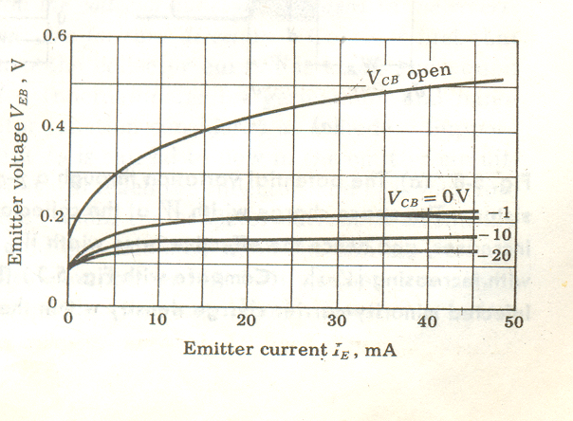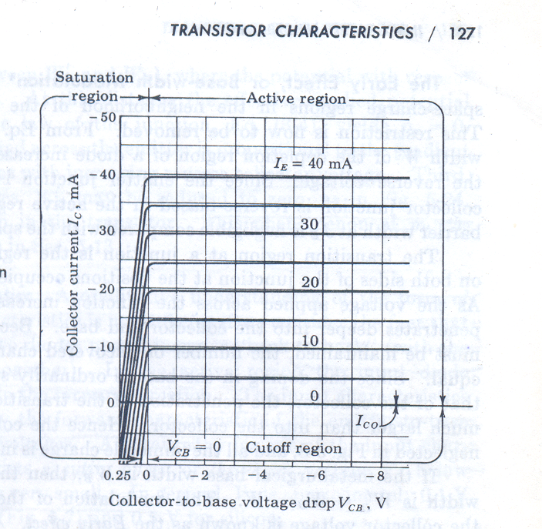

Fig.3

hib = [Δ VEB / Δ IE] at VCB = constant. hob = [Δ Ic / Δ VCB] at IE = constant.

hrb = [Δ VEB / Δ VCB] at IE = constant hfb = [Δ Ic / Δ IE] at VCB= constant

EXP-4

STATIC CHARACTERISTICS OF TRANSISTOR

IN COMMON EMITTER CONFIGURATION

**AIM:**

To obtain the input and output characteristics of given transistor in CE configuration.

**APPARATUS:**

i. Circuit board

ii. Ammeters (0-50mA) – 2 Nos.

iii. Voltmeters (0-1 V, 0-30 V)

iv. Patch cords.

v. Regulated Power Supply.

**1. Input Characteristics.**

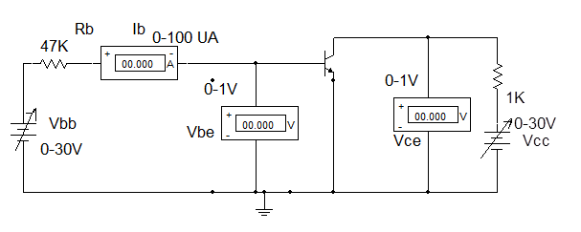

**Fig.1**

**Theory:**

These curves give the relationship between the base current (IB) and the base to emitter voltage (VBE) for a constant collector to emitter voltage (VCE). As the collector to emitter voltage is increased above 1V, the curves shifts down wards because as VCE is increased, the depletion width in the base region increases and this reduces the effective base width, which in turn reduces the base current.

**Procedure :**

i.Connect the circuit as shown in Fig-1.

ii. Ensure that the power supply is switched OFF. Keep the voltage control knob in the minimum position and current control knob in maximum position.

iii.Switch ON the power supply. Adjust VCC such that VCE=0V (this can also be done by Switching OFF the Vcc supply and shorting the two outputs leads. Vary IB with the help of VBB in steps of 10µA and record the corresponding values of VBE in the Table –I shown below and record the corresponding values of V BE (base to emitter voltage).

iv. Make sure that the collector current Ic does not exceed 25mA. This set of readings gives the input characteristics of VCE=0V.

v. Repeat steps (1-4) for different values of VCE say VCE =0.1 v, 0.2V, 0.3V, 1V.

vi. Draw input characteristic IB Vs VBE for different values of VCE.

vii. Estimate h-parameters from the characteristic curves.

viii. Present all the results at the end of the experiment.

**Table – I: Input Characteristics**

|  |  |  |  |  |  |  |  |  |
| --- | --- | --- | --- | --- | --- | --- | --- | --- |
| SNO | VCE=0V | | VCE=0.2V | | VCE=0.4V | | VCE=1V | |
|  | IB  (μ Amp) | VEB  (V) | IB  (μ Amp) | VEB  (V) | IB  (μ Amp) | VEB  (V) | IB  (μ Amp) | VEB  (V) |
|  |  |  |  |  |  |  |  |  |

**2. Output Characteristics**:

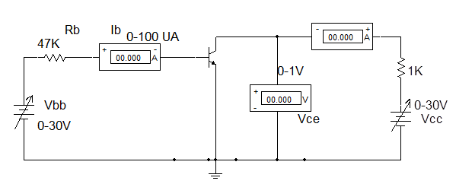

**Fig.2**

**Theory:**

Output characteristic gives the relationship between the collector to emitter voltage (VCE) and collector current(IC) for a constant base current (IB).

The curves may be divided into three important regions namely Saturation region Active region and Cut-off region.

**Procedure:**

i. Connect the circuit as per the Diagram shown in Fig – 2

ii. Ensure that the power supply is switched OFF. Keep the voltage control knob in the minimum position and current control knob in maximum position. Switch ON the power supply.

iii. With the help of power supply VEE make the input current IB=10μA. Vary collector to

Emitter voltage (VCE) in suitable steps of 0.1 volts starting from 0 volts. Record the

corresponding values of collector currents IC, in the Table-II. This set of readings gives

the output characteristics for IB=10μA.

iv. Repeat step iii for different values of base current say Ib=10μA-100μA in steps of 10μA.

v. Draw the output characteristic Vce vs IC.

vi. Estimate h-parameters from the characteristics curve.

vii. Present all the results at the end of the experiment.

Table-II: Output Characteristics

|  |  |  |  |  |
| --- | --- | --- | --- | --- |
| **S.No.** | IB=20μA | IB=40μA | IB=60μA | IB=80μA |

|  |  |  |  |  |  |  |  |  |
| --- | --- | --- | --- | --- | --- | --- | --- | --- |
|  | VCE  (Volts) | IC  (mA) | VCE  (Volts) | IC  (mA) | VCE  (Volts) | IC  (mA) | VCE  (Volts) | IC  (mA) |

|  |  |  |  |  |  |  |  |  |
| --- | --- | --- | --- | --- | --- | --- | --- | --- |
|  |  |  |  |  |  |  |  |  |

**Results:**

The input and output characteristics are drawn & are shown in Fig.3(a)and Fig.3(b). The e following hybrid parameters are estimated from the graphs.

From the input characteristics

hie= ΔVBE/ ΔIb at VCE= constant.

hre= ΔVBE/ ΔVCE at Ib= constant.

From the output characteristics

hoe= ΔIc / ΔVCE at IB=constant.

hfe= ΔIc / ΔIb at VCE= constant

**Discussions :**

i. Indicate the various regions, (Active region, Saturation region and cut off region) on

the out put characteristics of the transistor.

ii. Estimate Ic and Vce from the circuit shown

iii.What are the differences between common emitter and common base input and out

put characteristics?

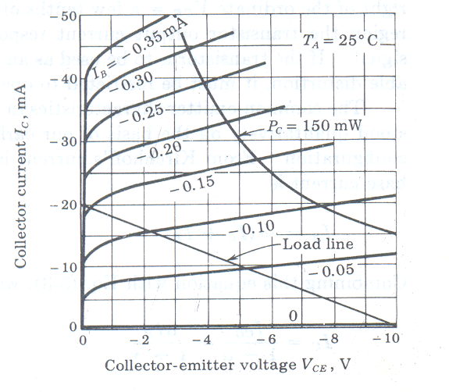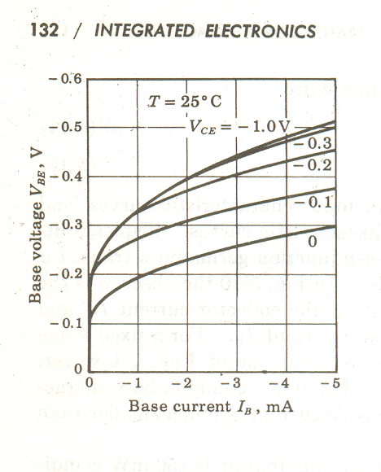 Input Characteristics Output Characteristics

hie= Δ VBE/ Δ IB at VCE= constant. hoe= Δ Ic / Δ VCE at IB= constant.

hre=Δ VBE/ Δ VCE at IB= constant hfe= Δ Ic / Δ IB at VCE =constant

EXP-5

STATIC CHARACTERISTICS OF TRANSISTOR

IN COMMON COLLECTOR CONFIGURATION

**Aim:**

To obtain the input and output characteristics of given transistor in CC configuration.

**Apparatus:**

1. Circuit board containing BC107 / CL100 Transistor & Resistors

2. Ammeters (0-50mA) – 2 Nos.

3. Voltmeters (0-1 V, 0-30 V)

4. Patch cords.

5. Regulated Power Supply.

1. **Input Characteristics :**

The Circuit diagram for the study of input characteristics of a Transistor in common-collector configuration is shown in

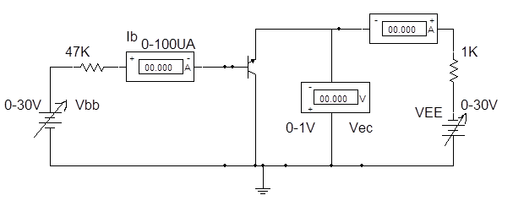

**Fig.1**

Theory :

Input characteristic curves give the relationship between the base current (IB) and the base to collector voltage (VBC) for a constant collector to base voltage (VEC)

Procedure :

i. Connect the circuit as shown in Fig-1.

ii. Ensure that the power supply is switched OFF. Keep the voltage control knob in the

minimum position and current control knob in maximum position.

iii. Switch ON the power supply. Adjust VEC =2V

iv. Vary IB with the help of VBB in steps of 10µA and record the corresponding values of VBC in the Table –I. Make sure that the collector current IC does not exceed 25mA.

v. Repeat steps from i to iv for different values of VEC say VEC =5V, 10V and for VBC open (This can be done by opening one of the output terminals).

vi. Draw the input characteristics IB verses VBC for different values of VEC in Fig.3(a).

vii. Estimate h-parameters from the characteristics curve.

viii. Present all the results at the end of the experiment

Table – I Input Characteristics

|  |  |  |  |  |  |  |  |  |
| --- | --- | --- | --- | --- | --- | --- | --- | --- |
| S.No. | VCE =2V | | VCE =5V | | VCE =10V | | VCE =open | |
| IB  (µA) | VBC  (Volts) | IB  (µA) | VBC  (Volts) | IB  (µA) | VBC  (Volts) | IB  (µA) | VBC  (Volts) |
| 1.  2.  3.  4.  5.  6.  7. | 0  5  10  20  30  40  50 |  | 0  5  10  20  30  40  50 |  | 0  5  10  20  30  40  50 |  | 0  5  10  20  30  40  50 |  |

Output Characteristics :

The Circuit diagram for the study of output characteristics of a Transistor in common-collector configuration is shown in Fig.2

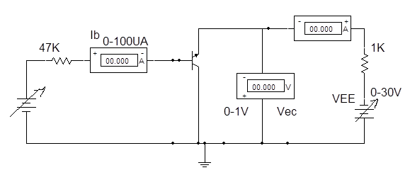

Fig.2

Theory :

The output characteristics curves give the relationship between collector to emitter voltage (VEC) and the emitter current (IE)

Procedure :

i. Connect the circuit as shown in Fig-2.

ii. Ensure that the power supply is switched OFF. Keep the voltage control knob in the

minimum position and current control knob in maximum position.

1. Switch ON the power supply. Adjust Ib=20µA
2. Fix the base current volue(Ib) . Record the corresponding values of emitter current (IE) by varying the volues of VCE from 1 TO 20 in the steps of 2V by adjusting VEE.
3. Repeat steps from i to iv for different values of Ib say Ib=0µA,40µA,60µ
4. Draw the output characteristics for different values of VEC in Fig.3(b).
5. Present all the results at the end.

Table – II Output Characteristics

|  |  |  |  |  |  |  |  |  |  |  |
| --- | --- | --- | --- | --- | --- | --- | --- | --- | --- | --- |
| S.No. | IB=20(µA) | | IB=40(µA) | | IB=60(µA) | | IB=80(µA) | | IB=100(µA) | |
|  | VEC  (Volts) | IE  (mA) | VEC  (Volts) | IE  (mA) | VEC  (Volts) | IE  (mA) | VEC  (Volts) | IE  (mA) | VEC  (Volts) | IE  (mA) |
| 1.  2.  3.  4.  5.  6.  7. |  |  |  |  |  |  |  |  |  |  |

**Results :**

The input and output characteristics are drawn and the following hybrid parameters are estimated from the graphs.

hic = Δ VBC / Δ Ib at VEC= constant.

Hrc = Δ VBC / Δ VEC at IB= constant.

Are computed from the input characteristics

hoc = Δ IE / Δ VEC at IB=constant.

Hfc = Δ IE / Δ IB at VEC= constant

Are computed from the output characteristics

Discussions : Indicate the various regions (Active region, Saturation region and cut-off region) on the output characteristics of the transistor and discuss them.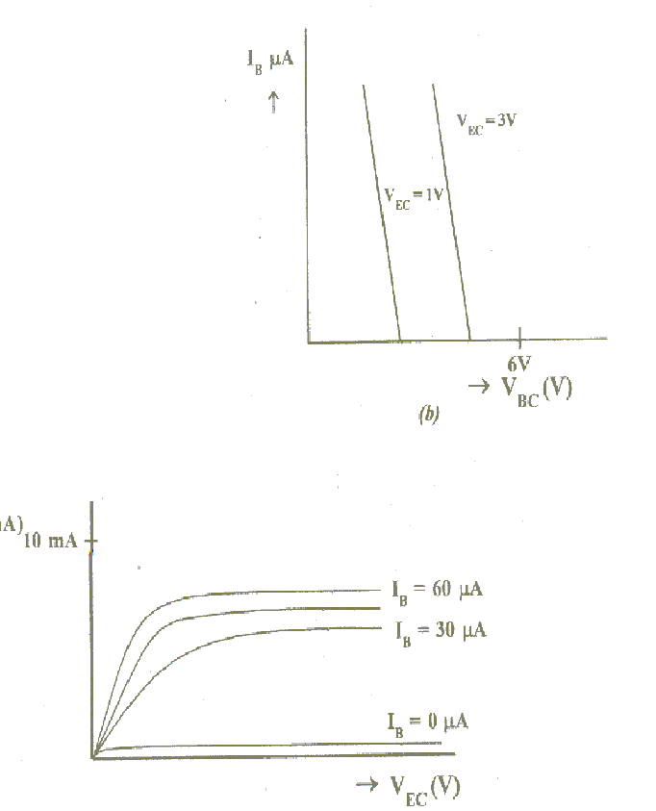

hic = Δ VBC / Δ Ib at VEC= constant. hoc = Δ IE / Δ VEC at IB=constant.

hrc = Δ VBC / Δ VEC at IB= constant. hfc = Δ IE / Δ IB at VEC= constant

EXP-6

FIELD EFFECT TRANSISTOR - STATIC CHARACTERISTICS

**Aim** :

a) To obtain the static characteristics (output and transfer characteristics) of a given Field Effect Transistor (FET).

b) Identify the Ohmic, Pinch-off and breakdown regions of the characteristics and

c) To estimate the values of drain resistance (rd), trans-conductance gm and the amplification factor –A from the characteristics.

**Apparatus** :

i. Circuit board with a FET, Diode, Resistors, BFW10, OA79

ii. Milli Ammeters (0-25mA)

iii. Voltmeter (0-30 V)

iv. Patch cords

v. Regulated Power Supply

**Circuit Diagram**:

The circuit diagram for studying the characteristics of a FET is shown in Fig.1



**Theory:**

The Field effect Transistor is a three terminal unipolar device in which the current through the device is controlled by the electric field, unlike the case of bipolar transistors. Hence, they offer very high input impedance compared to bipolar devices. A reverse biased diode is included in the path of the gate to protect the FET from any accidental forward biasing. A high input impedance digital voltmeter should be connected between the gate and source.

**(i). Drain Characteristics or output characteristics**:

These curves give the relationship between the drain to source voltage Vds and drain current Id for different values of gate to source voltage Vgs. As Vgs is increased pinch-off voltage is reached at lower value of drain current and Vds also decreases as compared to that when Vgs is zero.

**(ii). Transfer characteristics or input characteristics:**

These curves gives the relationship between drain current Id and gate to source voltage Vgs for different values of drain to source voltage Vds. These are also called as Trans-conductance curves.

**Procedure:**

i. Make the connections as shown in the circuit Diagram shown in fig-1.

ii. Ensure that the power supply is switched OFF. Keep the voltage control knob

in the minimum position and current control knob in maximum position.

**Output characteristics:**

Set Vgs = -1Volts by varying Vgg. Gradually increase the drain to source voltage by varying V dd from 0 – 10 Volts in steps of I volt and note down the drain current Id .

ii. Repeat this for V gs = -2 Volts and V gs = -3.0 Volts.------------------

iii. Record the observations in Table-I

iv. Plot V ds versus Id for different values of V gs.

v. Draw the output characteristics V ds versus Id as shown in Fig.2(a), and calculate

the drain resistance rd from the graph in the linear region of the characteristics by

rd = [ΔVds / ΔId] at V gs = constant.

vi. Present all the results at the end of the experiment.

TABLE-I : Output characteristics

|  |  |  |  |  |  |  |  |  |
| --- | --- | --- | --- | --- | --- | --- | --- | --- |
| S.No. | V gs =- 0.0V | | V gs = -1V | | V gs =-2V | | Vgs =-3V | |
| Vds(V) | Id (mA) | Vds (V) | Id (mA) | Vds (V) | Id (mA) | Vds (V) | Id (mA) |
|  | 0.0  1.0  -  -  -  -  10.0 |  |  |  |  |  |  |  |

## Transfer characteristics:

i. Set V ds = 2 Volts by varying Vdd .

ii. Increase Vgs from 0 to 5 volts in steps of 0.5 volts gradually and note down

the values for Id.

iii. Repeat this for V ds = 5 volts and V ds = 10 Volts.

iv. Plot the graph V gs versus Id for constant V ds as shown in Fig.2(b) and calculate the

Trans-conductance (gm) from the graph in the linear region of the characteristics

g m = [ΔId/ΔV gs] at V ds = constant.

v. Present all the results at the end of the experiment.

TABLE-II : Transfer characteristics

|  |  |  |  |  |  |
| --- | --- | --- | --- | --- | --- |
| V ds = 2 V | | V ds = 4 V | | V ds = 6 V | |
| Vgs (V) | Id (mA) | Vgs (V) | Id (mA) | Vgs (V) | Id (mA) |
|  |  |  |  |  |  |

**Discussions:**

i. Why FET is called unipolar device?

ii. What are the differences between FET& UJT?

iii. Why FET is called voltage control device?

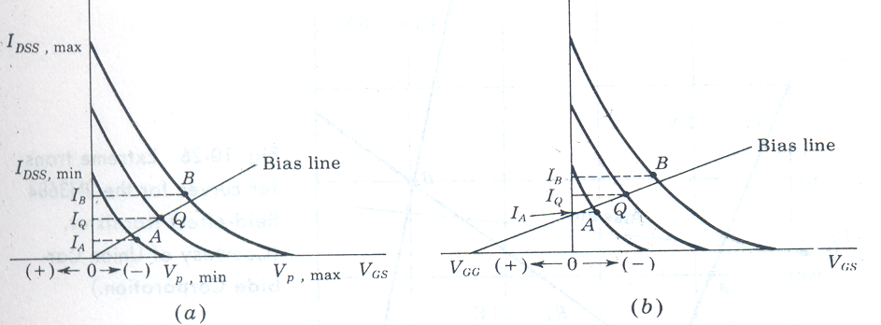

Transfer Characteristics

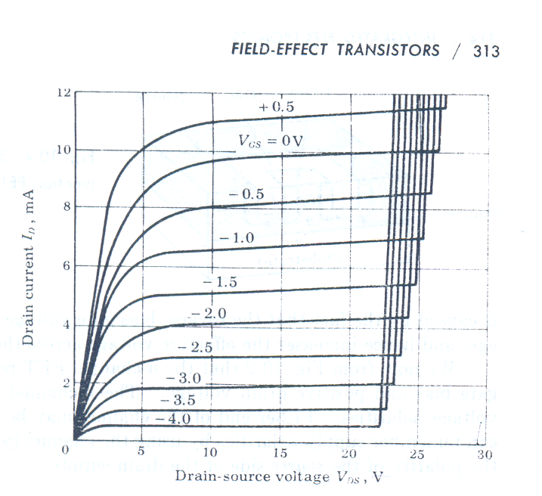Drain or Output Characteristics

**RESULT:**

1.The parameters of the FET are

Drain resistance rd =

Transconductance gm =

Amplification factor μ = rd . gm

### EXP-7

## FREQUECY RESPONSE OF C.E AMPLIFIER

**AIM ;**

1. To obtain maximum signal handling capacity (over load characteristic) by plotting the out put voltage verses the input voltage a fixed frequency of 1 KHz (in the mid frequency band).
2. To measure the I/P impedance and O/P impedance of the amplifier.
3. To obtain the frequency response of the amplifier

a) Gain Vs Frequency b) Phase difference Vs Frequency.

**APPARATUS:** C.R.O , D.C Regulated power supply , signal generator , transistor BC107, resistors, capacitors, bread board, patch cords.

**CIRCUIT DIAGRAM :**



**PROCEDURE :**

1. Connect the circuit as shown in figure, and check for the D.C conditions of the transistor to ensure that it is in active region . Obtain the maximum signal handling capacity (also known as over load characteristic) at constant input signal frequency of 1 KHz as follows (i.e), Vary the input voltage from 0 to 2V in suitable steps 10mV.

Plot the characteristic of out put voltage Vs input voltage. Indicate the point where the distortion begins to set in the O/P. The corresponding amplitude of the I/P voltage gives the maximum signal handling capacity for the amplifier.

2.

a) Measurement of input impedance :

Fix the frequency at 1KHz note the values of Vs ,Vi and calculate the input impedance Zi by using the following equations.

Iin = (Vs – Vi) / Rs Zi = Vi / Iin.

b) Measurement of out put impedance :

At 1KHz frequency note the un-load o/p voltage V0. Then Connect a decade resistance box across the O/P terminals and adjust its value such that V0 falls to half of the unloaded value. The reading on the decade resistance box gives the value of out put impedance Z0.

3. Gain Vs frequency response :

1. Keeping the input voltage constant (below maximum signal handling capacity) vary the frequency from 10 Hz onwards in suitable steps up to a frequency where the out put voltage falls to less than half of the maximum out put voltage in the mid band.
2. Plot a graph of gain (Vo/Vi) Vs frequency on a semi log graph sheet and determine the bandwidth.

**OBSERVATIONS :**

Vi = voltsrms.

|  |  |  |  |  |
| --- | --- | --- | --- | --- |
| S.NO | FREQUENCY | Vo (V) | Av = (Vo/Vi) | Av(db)=20 log(Vo/Vi) |
|  |  |  |  |  |

b) Phase difference Vs frequency response :-

1. Using C.R.O measure the phase difference between Vin and Vout as the frequency of the input signal is varied in suitable steps and tabulate the results as shown below. Plot the phase Vs frequency.

|  |  |  |  |
| --- | --- | --- | --- |
| FREQUENCY OFI/P SIGNAL | a | b | Ø = invers sin(b/a) |
|  |  |  |  |

Note : Find the phase difference between the input and the output signals at 2 or 3 frequencies in the lower frequency, mid-frequency and the High –frequency segments of the characteristic.

**MODEL GRAPHs:**

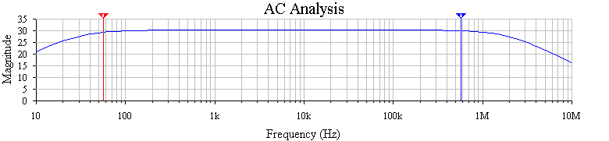

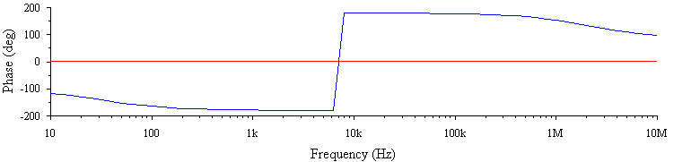

**RESULT :**

|  |  |  |  |
| --- | --- | --- | --- |
| SNO | PARAMETER | THEORITICAL | EXPERIMENTAL |
| 1.  2.  3.  4.  5.  6.  7.  8. | Maximum signal handling capacity  Input impedance  Out put impedance  Mid band voltage gain  3db gain  Lower half power frequencyf1=very small  Upper half power Frequency f2  Band width B=(f2-f1) = f2 |  |  |

**RESULTS & DISCUSSION :**

1. The phase difference between in put and out put for an emitter follower at the mid frequency is -----------------.
2. For emitter follower which parameter or characteristics are highest compare it with C.B configuration.
3. Operation of emitter follower.
4. The feed back used in emitter follower --------------------.

## EXP-8

## FREQUENCY RESPONSE OF CS AMPLIFIER

**AIM ;**

1. To obtain maximum signal handling capacity (over load characteristic) by plotting the out put voltage verses the input voltage a fixed frequency of 1 KHz (in the mid frequency band).
2. To measure the I/P impedance and O/P impedance of the amplifier.
3. To obtain the frequency response of the amplifier

a) Gain Vs Frequency b) Phase difference Vs Frequency.

**APPARATUS:** C.R.O , D.C Regulated power supply , signal generator , transistor BC107, resistors, capacitors, bread board, patch cords.

**CIRCUIT DIAGRAM :**



**PROCEDURE :**

1. Connect the circuit as shown in figure, and check for the D.C conditions of the transistor to ensure that it is in active region . Obtain the maximum signal handling capacity (also known as over load characteristic) at constant input signal frequency of 1 KHz as follows (i.e), Vary the input voltage from 0 to 2V in suitable steps 10mV.

Plot the characteristic of out put voltage Vs input voltage. Indicate the point where the distortion begins to set in the O/P. The corresponding amplitude of the I/P voltage gives the maximum signal handling capacity for the amplifier.

2.

a) Measurement of input impedance :

Fix the frequency at 1KHz note the values of Vs ,Vi and calculate the input impedance Zi by using the following equations.

Iin = (Vs – Vi) / Rs Zi = Vi / Iin.

b) Measurement of out put impedance :

At 1KHz frequency note the un-load o/p voltage V0. Then Connect a decade resistance box across the O/P terminals and adjust its value such that V0 falls to half of the unloaded value. The reading on the decade resistance box gives the value of out put impedance Z0.

3. Gain Vs frequency response :

1. Keeping the input voltage constant (below maximum signal handling capacity) vary the frequency from 10 Hz onwards in suitable steps up to a frequency where the out put voltage falls to less than half of the maximum out put voltage in the mid band.
2. Plot a graph of gain (Vo/Vi) Vs frequency on a semi log graph sheet and determine the bandwidth.

OBSERVATIONS :

Vi = volts.

|  |  |  |  |  |
| --- | --- | --- | --- | --- |
| S.NO | FREQUENCY | Vo (V) | Av = (Vo/Vi) | Av(db)=20 log(Vo/Vi) |
|  |  |  |  |  |

b) Phase difference Vs frequency response :-

1. Using C.R.O measure the phase difference between Vin and Vout as the frequency of the input signal is varied in suitable steps and tabulate the results as shown below. Plot the phase Vs frequency.

|  |  |  |  |
| --- | --- | --- | --- |
| FREQUENCY OFI/P SIGNAL | a | b | Ø = invers sin(b/a) |
|  |  |  |  |

Note : Find the phase difference between the input and the output signals at 2 or 3 frequencies in the lower frequency, mid-frequency and the High –frequency segments of the characteristic.

**MODEL GRAPHs:**

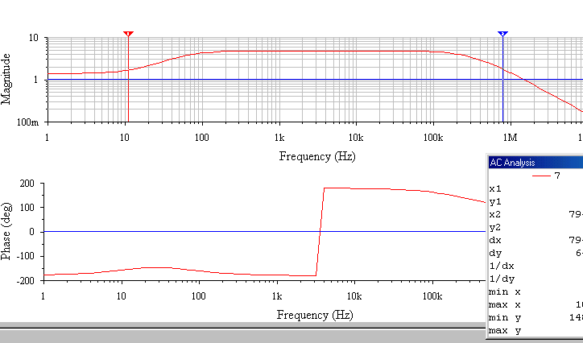

|  |  |  |  |
| --- | --- | --- | --- |
| SNO | PARAMETER | THEORITICAL | EXPERIMENTAL |
| 1.  2.  3.  4.  5.  6.  7.  8. | Maximum signal handling capacity  Input impedance  Out put impedance  Mid band voltage gain  3dbgain Lower half power frequencyf1=very small  Upper half power frequency f2  Band width B=(f2-f1) = f2 |  |  |

**RESULTS & DISCUSSION :**

1. The phase difference between in put and out put for common source FET amplifier at the mid frequency is -----------------.

**EXP-9**

## MEASUREMENT OF RESISTANCE USING WHEATSTONE BRIDGE







Tabulation of Measured Data:

|  |  |  |  |  |  |
| --- | --- | --- | --- | --- | --- |
| **S.No** | **RX(Applied)(K**Ω**)** | **Ratio(R3/R2)** | **R1(Measured)(K**Ω**)** | **RX(Measured)(K**Ω**)** | **% Error** |
| 1 |  | 0.1 |  |  |  |
| 2 |  | 0.1 |  |  |  |
| 3 |  | 0.1 |  |  |  |
| 4 |  | 1 |  |  |  |
| 5 |  | 1 |  |  |  |
| 6 |  | 1 |  |  |  |
| 7 |  | 1 |  |  |  |
| 8 |  | 10 |  |  |  |
| 9 |  | 10 |  |  |  |
| 10 |  | 10 |  |  |  |

###### Result:

The Unknown Resistance Rx has been measured with help of Wheat Stone Bridge.

**EXP-10**

**MEASUREMENT OF RESISTANCE USING KELVIN BRIDGE**







1. Adjust the Vary the Knob of the Potentiometer ***S*** so that the Balance/ Null point can be observed in the Multi – Meter. Note down the Value of S for which the Balance Condition has been obtained.
2. Set the Unknown Resistance Rx to different values as shown in Table and tabulate the corresponding values of the Balancing Resistor S.
3. Proceed to performing calculations of Rx from the values of the Resistance Values of S for which the Balance Condition in the Wheat Stone Bridge is obtained.
4. Find the error in measurement of Rx in Table, by calculating the values of Rx from the values of the Balancing Resistors S and comparing them with the actual values.

**Calculation:**

$$Rx\left(measured\right)=S\left(measured\right)*\frac{P}{Q}$$

$$\%Error=\frac{Rx\left(applied\right)-Rx(measured) }{Rx(applied)}*100$$

###### Tabulation of Measured Data:

|  |  |  |  |  |  |  |
| --- | --- | --- | --- | --- | --- | --- |
| **S.No** | **RX(Applied) (Ω)** | **Ratio (P/Q)** | **S(Measured)(Ω)** |  | **RX(Measured)(KΩ)** | **% Error** |
| 1 |  |  |  |  |  |  |
| 2 |  |  |  |  |  |  |
| 3 |  |  |  |  |  |  |
| 4 |  |  |  |  |  |  |
| 5 |  |  |  |  |  |  |
| 6 |  |  |  |  |  |  |
| 7 |  |  |  |  |  |  |
| 8 |  |  |  |  |  |  |

Result:

The Unknown Resistance Rx has been measured with help of Kelvin’s Bridge.

**EXP-11**

## MEASUREMENT OF CAPACITANCE USING SCHERING’S BRIDGE



* The De Sauty bridge is a deceptively simple bridge which is often used to produce an output voltage that is proportional to a small change, 𝛿C, in one of the capacitors, rather than to measure capacitance.





###### Circuit Diagram:

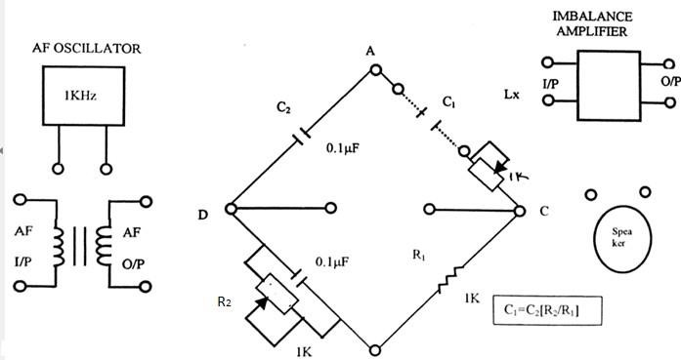



###### Calculations:

𝐶 = 𝑅2(𝑀𝑒𝑎𝑠𝑢𝑟𝑒𝑑) ∗ 𝐶

1(𝑀𝑒𝑎𝑠𝑢𝑟𝑒𝑑) 𝑅2 2

$$\%Error=\frac{C1\left(Applied\right)-C1(measured)}{C1(Applied)}*100$$

Tabulation of Measured Data:

|  |  |  |  |  |
| --- | --- | --- | --- | --- |
| **S.No** | **C1(Applied)** | **R2(Measured)(Ω)** | **C1(Measured)** | **% Error** |
| 1 |  |  |  |  |
| 2 |  |  |  |  |
| 3 |  |  |  |  |
| 4 |  |  |  |  |
| 5 |  |  |  |  |
| 6 |  |  |  |  |
| 7 |  |  |  |  |
| 8 |  |  |  |  |
| 9 |  |  |  |  |
| 10 |  |  |  |  |

Result:

The Unknown Capacitance C1 has been measured with help of Schering Bridge.

**EXP-12**

## MEASUREMENT OF INDUCTANCE USING MAXWELL’S BRIDGE AND MEASUREMENT OF L,C AND R USING Q-METER











Tabulation of Measured Data:

|  |  |  |  |  |  |
| --- | --- | --- | --- | --- | --- |
| **S.No** | **LX(Applied)** | **Multiplier Resistance(R2)** | **R3(Measured)(Ω)** | **LX(Measured)** | **% Error** |
| 1 |  | 100 KΩ |  |  |  |
| 2 |  | 100 KΩ |  |  |  |
| 3 |  | 10 KΩ |  |  |  |
| 4 |  | 10 KΩ |  |  |  |
| 5 |  | 1 KΩ |  |  |  |
| 6 |  | 1 KΩ |  |  |  |
| 7 |  | 100 Ω |  |  |  |
| 8 |  | 100 Ω |  |  |  |
| 9 |  | 10 Ω |  |  |  |
| 10 |  | 10 Ω |  |  |  |

Result:

The Unknown Inductance Lx has been measured with help of Maxwell’s Bridge.

**EXP-12B**

## MEASUREMENT OF R, L, C, AND Q FACTOR USING LCR-Q METER





###### Calculations:

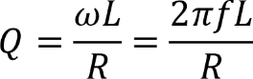

Tabulation of Measured Data

* 1. Resistance:

|  |  |  |
| --- | --- | --- |
| **#** | **Theoretical Value (Ω)** | **Value shown on LCR-Q Meter (Ω)** |
| 1 |  |  |
| 2 |  |  |
| 3 |  |  |
| 4 |  |  |
| 5 |  |  |

* 1. Capacitance:

|  |  |  |
| --- | --- | --- |
| **#** | **Theoretical Value (*µ*F)** | **Value shown on LCR-Q Meter (*µ*F)** |
| 1 |  |  |
| 2 |  |  |
| 3 |  |  |
| 4 |  |  |
| 5 |  |  |

* 1. Inductance:

|  |  |  |  |  |  |
| --- | --- | --- | --- | --- | --- |
| **#** | **Theoretical Value (mH)** | **Value shown on LCR-Q**  **Meter (mH)** | **Internal Resistance *R* (Ω)** | **Expected**  ***Q* factor** | ***Q* factor shown on LCR-Q meter** |
| 1 |  |  |  |  |  |
| 2 |  |  |  |  |  |
| 3 |  |  |  |  |  |
| 4 |  |  |  |  |  |
| 5 |  |  |  |  |  |

Result :

The values of various resistors, capacitors, and inductors are found using the LCR Q meter. The quality factor was also computed for these particular inductance values and was compared with the quality factor indicated by the LCR-Q meter.

**END**

